**Technical Documentation: Food Delivery Time Prediction Model**

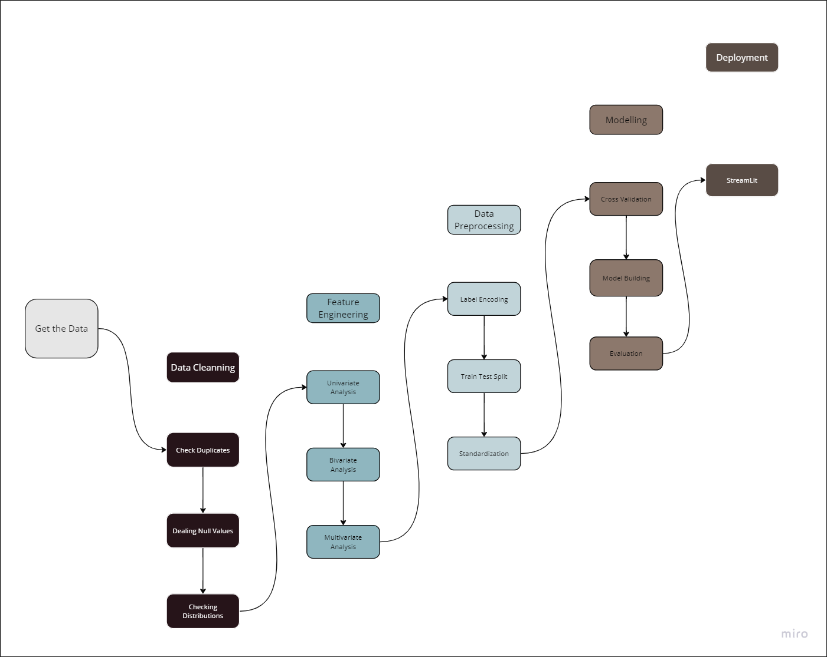

**Table of Contents**

* Project Overview
* Data Source
* Implementation Details
  + Methods Used
  + Technologies
  + Python Packages Used
* Steps Followed
* Results and Evaluation Criteria
* Future Improvements

**Project Overview**

This project focuses on developing a food delivery time prediction model. The primary goal is to accurately estimate the time it takes for food to be delivered to customers. By providing precise delivery time predictions, food delivery platforms can enhance customer experience, optimize delivery logistics, and improve overall operational efficiency.

**Data Source**

The dataset used for this project contains relevant information such as order details, location, city, delivery person information, weather conditions, and actual delivery times.

**Implementation Details**

**Methods Used**

* Machine Learning
* Data Cleaning
* Feature Engineering
* Regression Algorithms

**Technologies**

* Python
* Jupyter
* Streamlit

**Python Packages Used**

* Pandas
* NumPy
* Scikit-learn
* Matplotlib
* Seaborn
* XGBoost

**Steps Followed**

1. **Data Collection**: Gathered the food delivery dataset from the provided data source.
2. **Data Preprocessing**:
   * Performed data cleaning to handle missing values, outliers, and inconsistencies in the dataset.
   * Conducted feature engineering to extract relevant features for the prediction model.
3. **Model Development**:
   * Utilized regression algorithms to train a food delivery time prediction model.
   * Explored different models such as linear regression, decision trees, random forests, and XGBoost to identify the best-performing model.
4. **Model Evaluation**:
   * Evaluated the performance of the models using appropriate metrics such as mean squared error (MSE), root mean squared error (RMSE), and R-squared (R2) score.
5. **Deployment**:
   * Deployed the food delivery time prediction model as a standalone application for real-time predictions.

**Results and Evaluation Criteria**

Based on the evaluation results, the best-performing model was **XGBoost** with an R-squared (R2) score of **0.82**.

**Future Improvements**

Here are some potential areas for future improvements in the project:

* Incorporate more features related to delivery partners, weather conditions, or traffic patterns to enhance prediction accuracy.
* Conduct more comprehensive data analysis to identify additional patterns or correlations that can contribute to better predictions.
* Fine-tune the model parameters to potentially improve performance.